Phase 3 — Project Design Phase
Solution Architecture
Field | Value
Date | 15 February 2026
Team ID | SWTID-2026-1543
Project Name | Virtual Agent–Driven SLA Breach Awareness & Justification System
Maximum Marks | 4 Marks

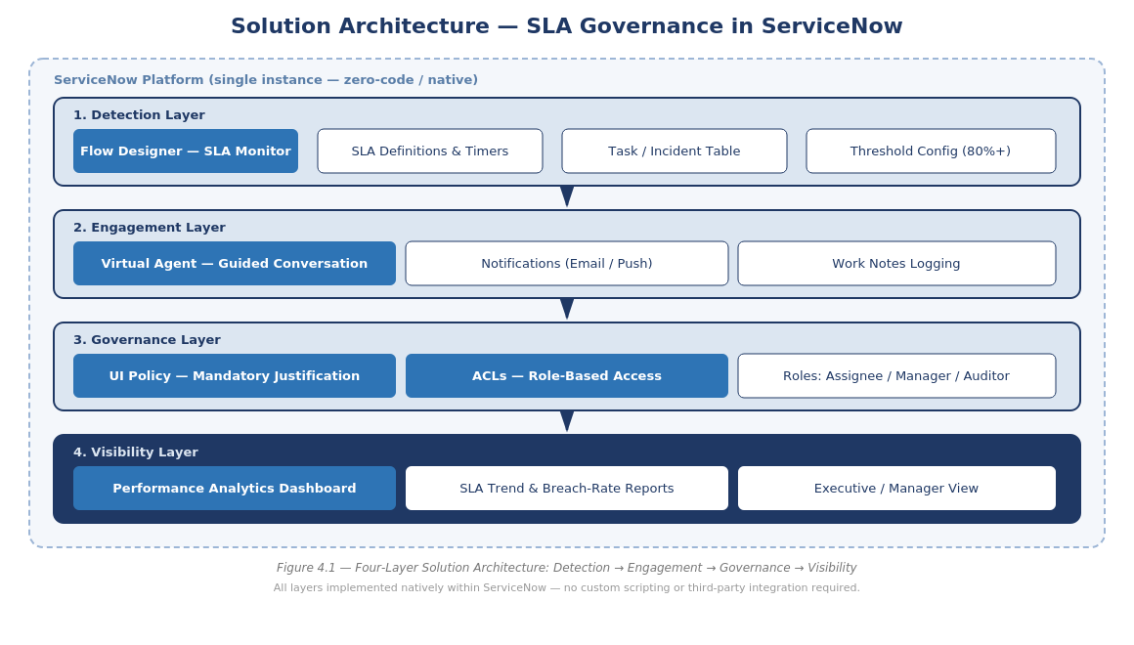
Figure 3.1 — Four-Layer Solution Architecture: Detection → Engagement → Governance → Visibility
The architecture is organized into four layers, all delivered natively within a single ServiceNow instance:
- Detection Layer — Flow Designer monitors SLA percentage-elapsed in real time against configurable thresholds.
- Engagement Layer — Notifications and the Virtual Agent inform and guide assignees through acknowledgement.
- Governance Layer — UI Policies and ACLs enforce mandatory justification and restrict unauthorized changes.
- Visibility Layer — Reports and an executive Performance Analytics dashboard provide trend and accountability tracking.

Component Responsibilities
Layer | Component | Responsibility
Detection | SLA Risk Monitor (Flow Designer) | Continuously evaluates task_sla.percentage against the configured threshold and sets the risk flag
Engagement | Notification Engine | Delivers the initial real-time alert to the assignee via ServiceNow notifications
Engagement | Virtual Agent Topic | Runs the guided conversation for acknowledgement and corrective-action selection
Governance | UI Policy | Makes the breach-justification field mandatory once the record is in breach status
Governance | Access Control Lists | Restrict write access to SLA-critical fields to the assignee role; read-only for manager/auditor
Visibility | Performance Analytics Dashboard | Aggregates SLA trend, breach-rate, and accountability metrics for management review

Deployment & Data Security View
The entire solution is packaged as a single ServiceNow Update Set, deployable to any instance without external infrastructure. All data — SLA definitions, task/incident records, risk flags, and justification text — remains within the native ServiceNow database, inheriting the platform's existing encryption-at-rest and role-based security model. No data leaves the instance and no external API calls are required, minimizing the solution's security and compliance surface area.

